FIELD REPORT
Introduction
- Place: Abela HC III
- Location: Abela, Oyam district
- Date of visit: 24th August 2026
General observations
- There were discrepancies between the assets reportedly delivered under UgIFT and those physically observed at the facility. For example, some items, including tables, were reported as having been delivered under UgIFT but were not available on the ground for verification.
- Conversely, some items appearing on the delivery documentation, such as glucometers, were physically present at the facility but were reported by facility staff as not having been provided under UgIFT. This created uncertainty regarding the source and program attribution of some assets.
- The differences between the delivery documentation, staff accounts, and the assets physically available at the facility made it difficult to establish a clear and consistent record of the assets supplied under UgIFT.

Asset verification
- Verification of all facility assets could not be fully completed because some rooms, including the OPD, were closed and the keys were not available during the visit. As a result, assets that may have been stored or in use within the inaccessible rooms could not be physically inspected or confirmed.
- The lack of access to some rooms, combined with discrepancies between the delivery documentation and assets observed on the ground, limited the completeness of the verification exercise and reconciliation of the UgIFT-supported assets.

Special notes
- The discrepancies observed suggest a need to reconcile the physical assets with the official delivery documentation and facility records to establish which items were supplied under UgIFT and which were obtained through other sources.
- The presence of assets that staff could not attribute to UgIFT, despite appearing on the delivery documentation, should be clarified through the relevant district/program records.

The table below illustrates some physical status of the verified assets with photographic evidence.
Table XXX: Physical verification photos
Weighing scale | 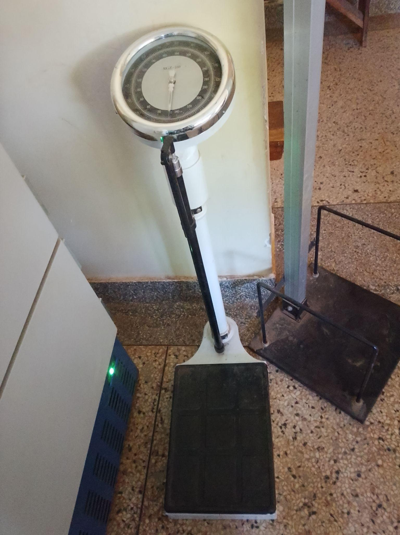
Waste bins | 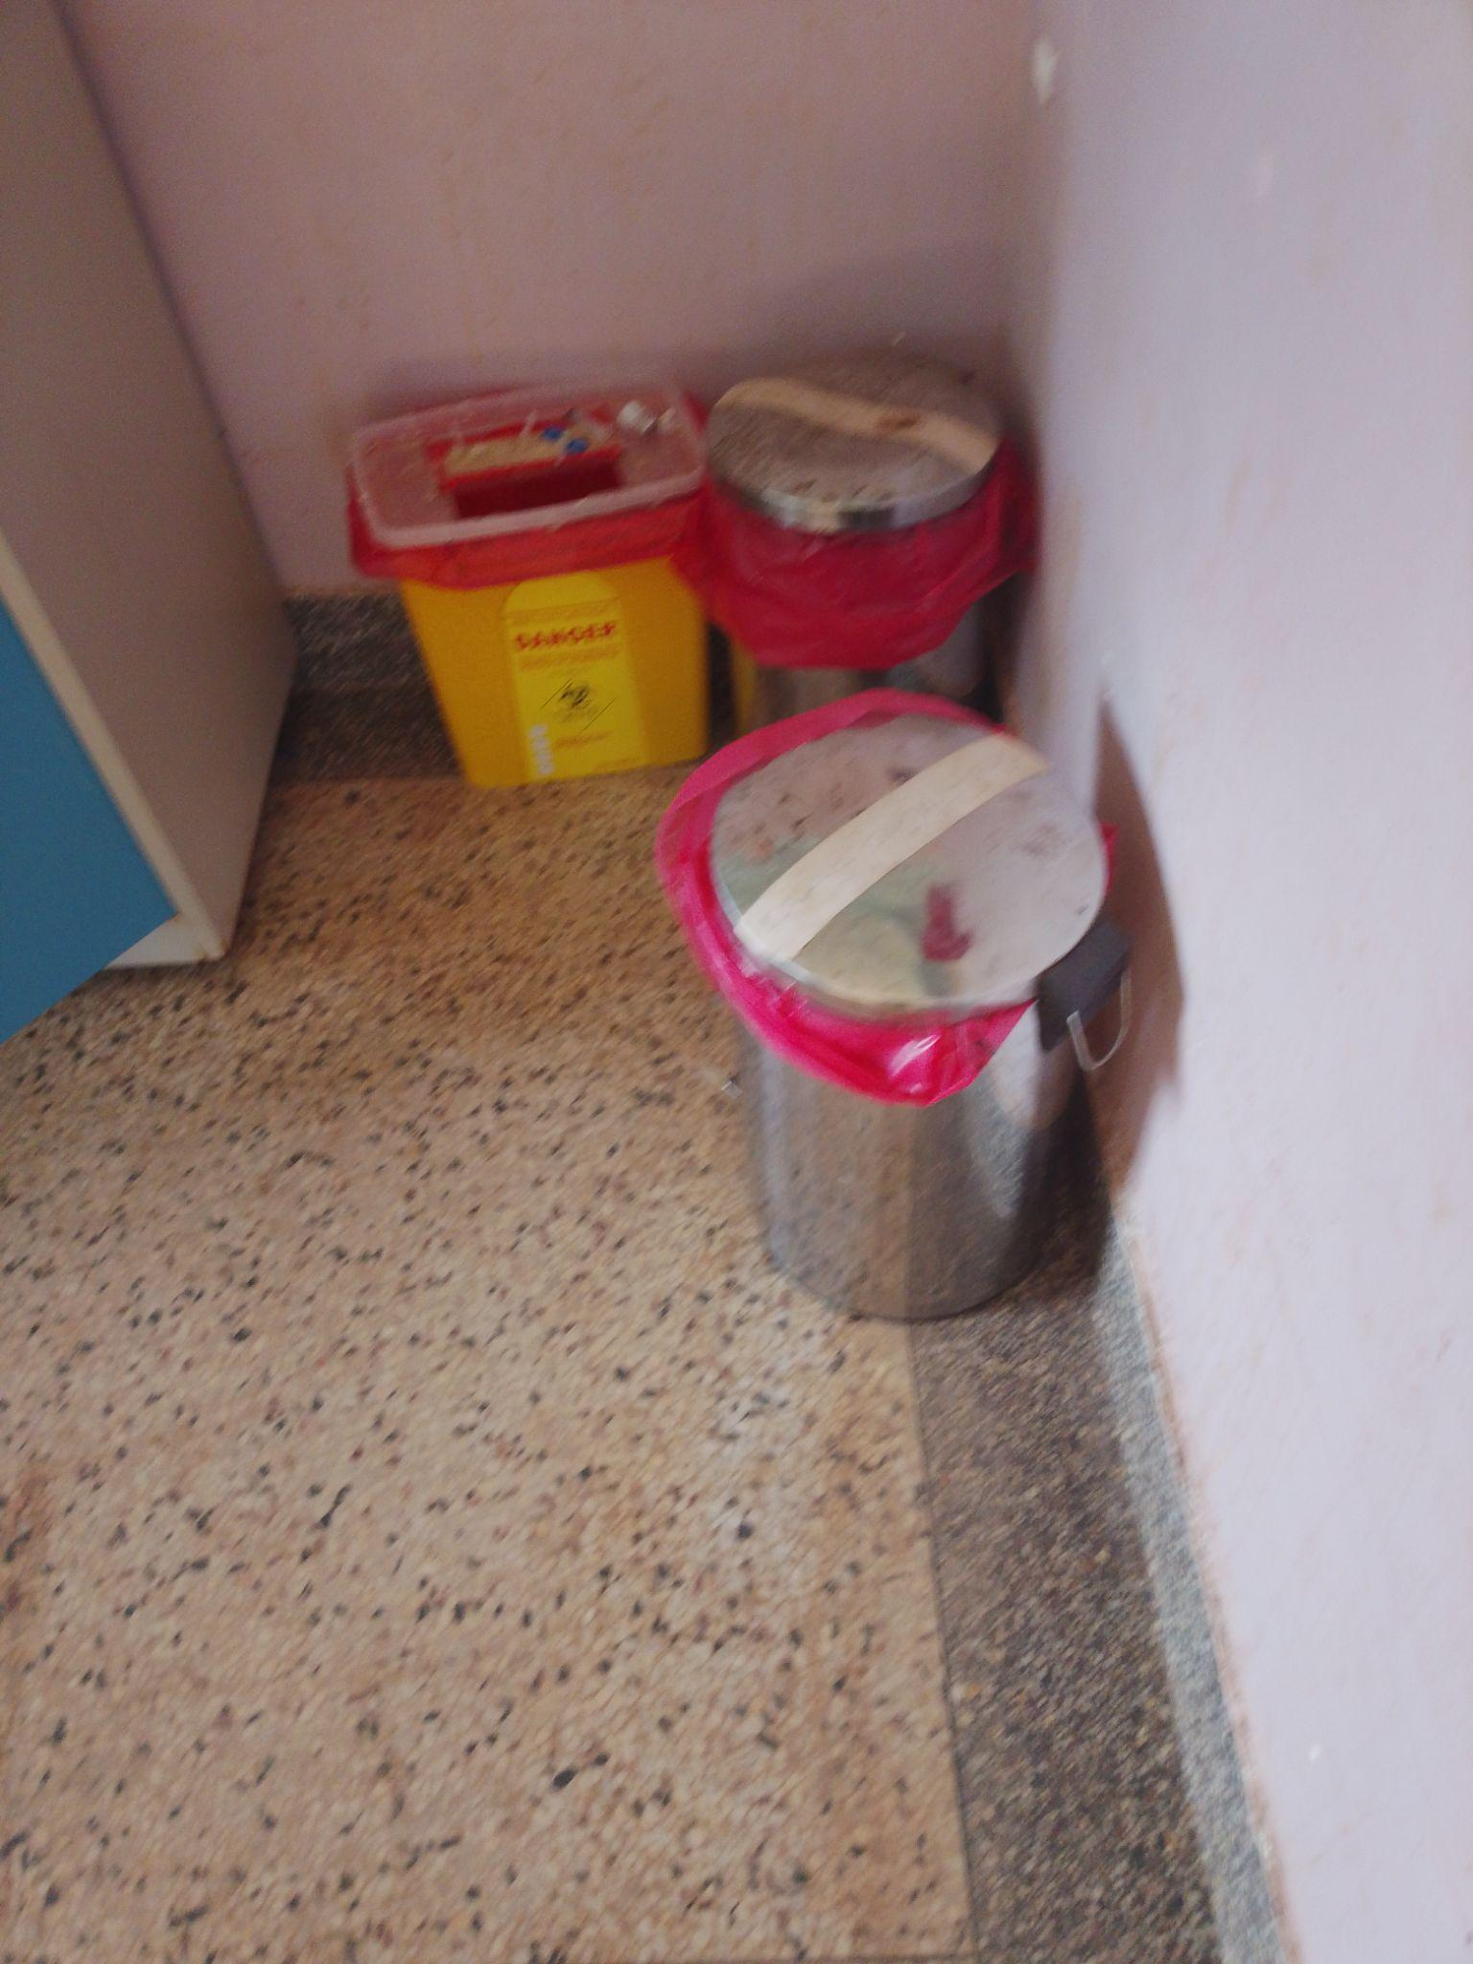
Examination bed | 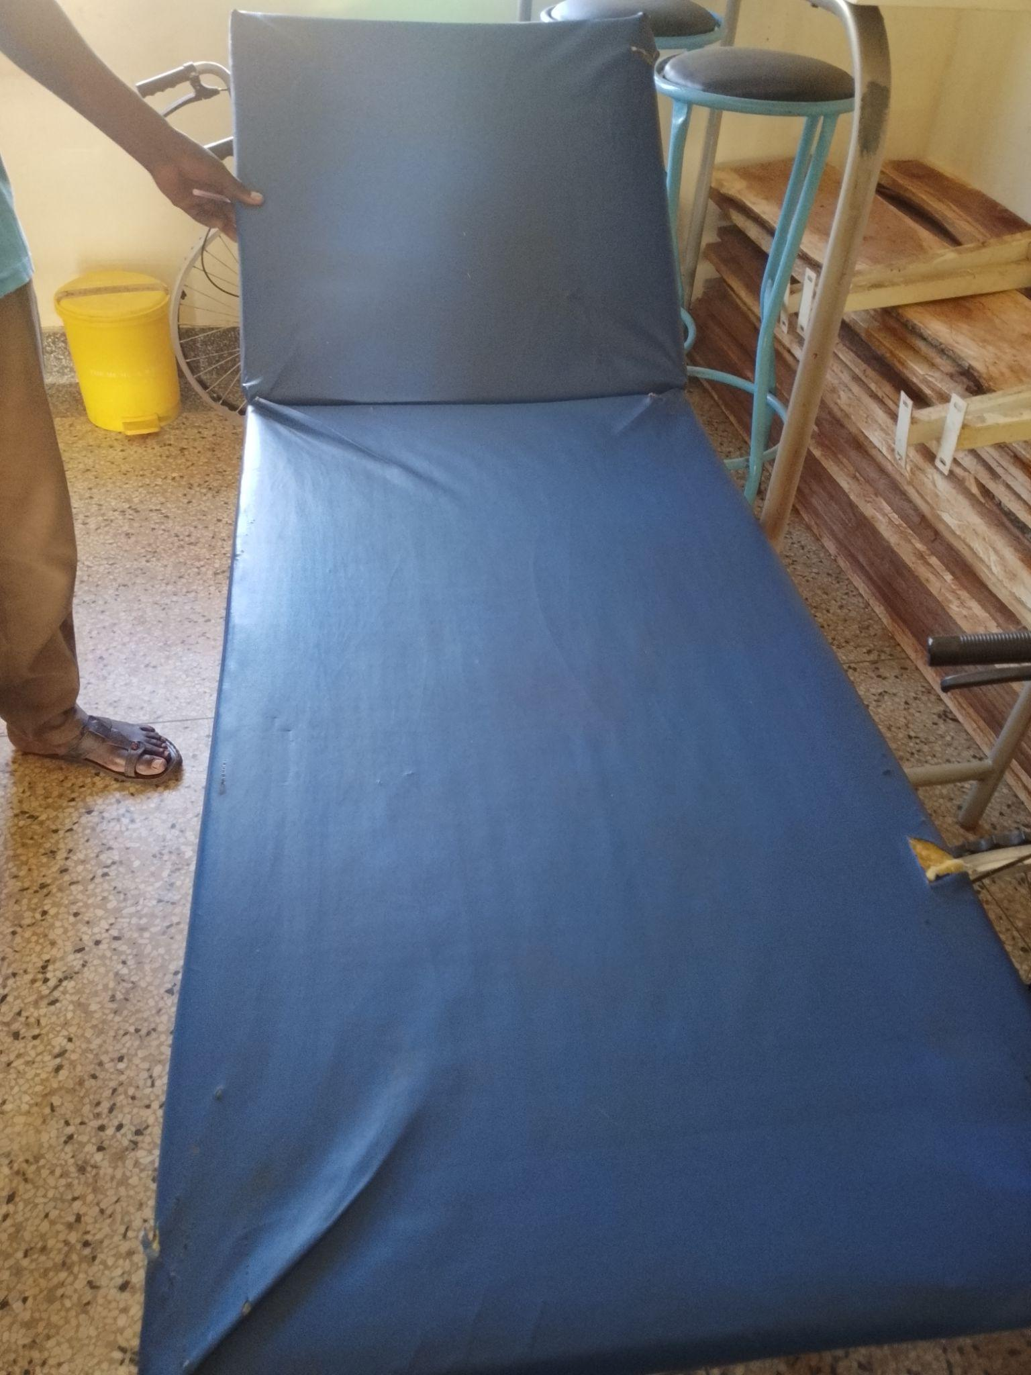
Refrigerator | 